**Video 10**

**CPU VS GPU Video Link is there in screenshot check it.  
Video on Attention Concept.**

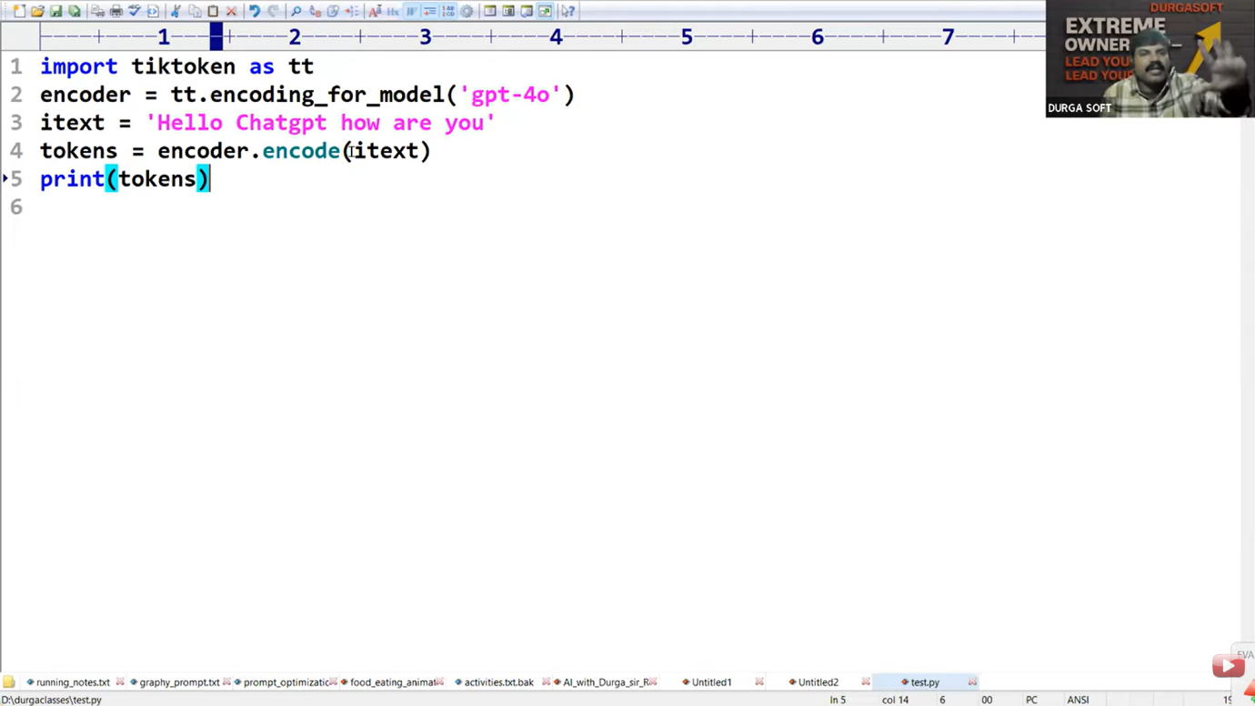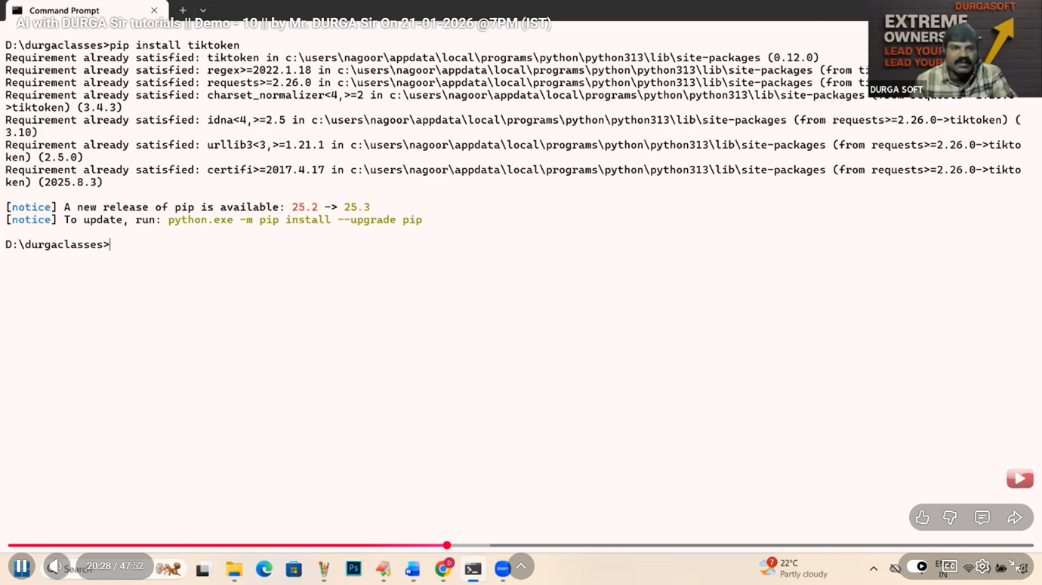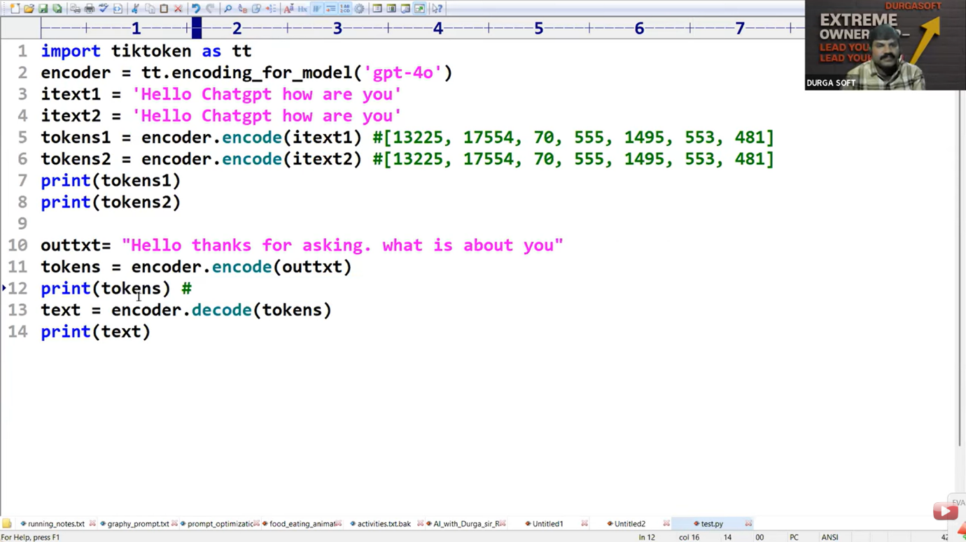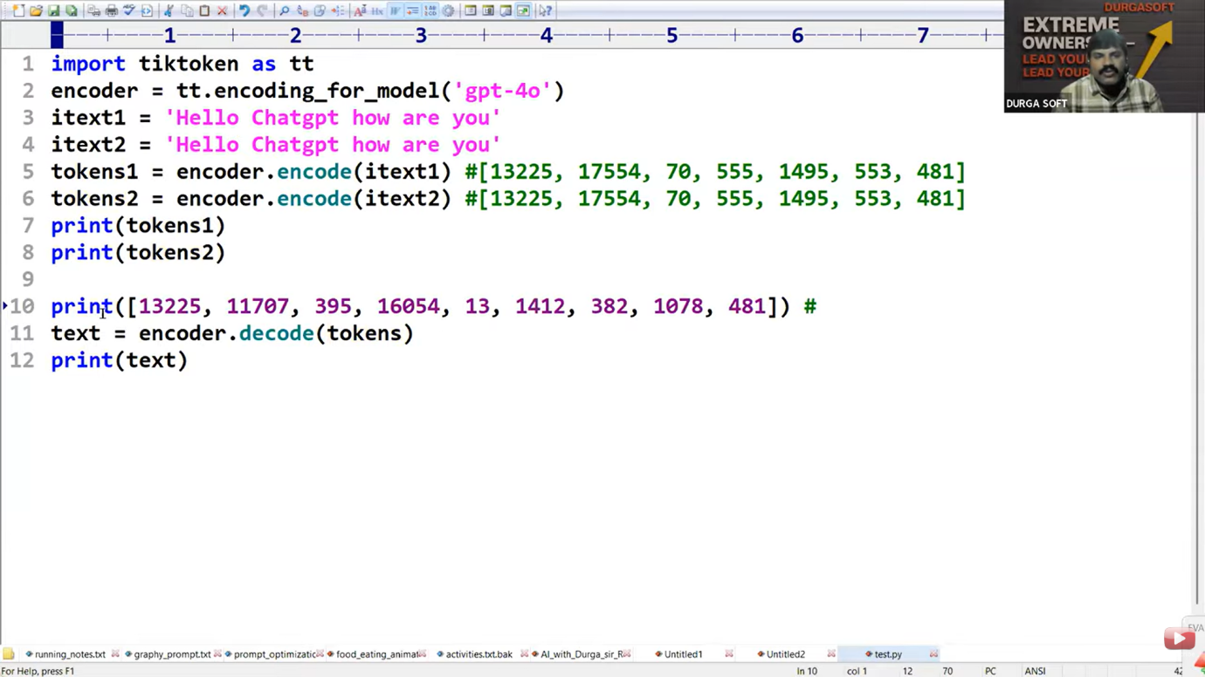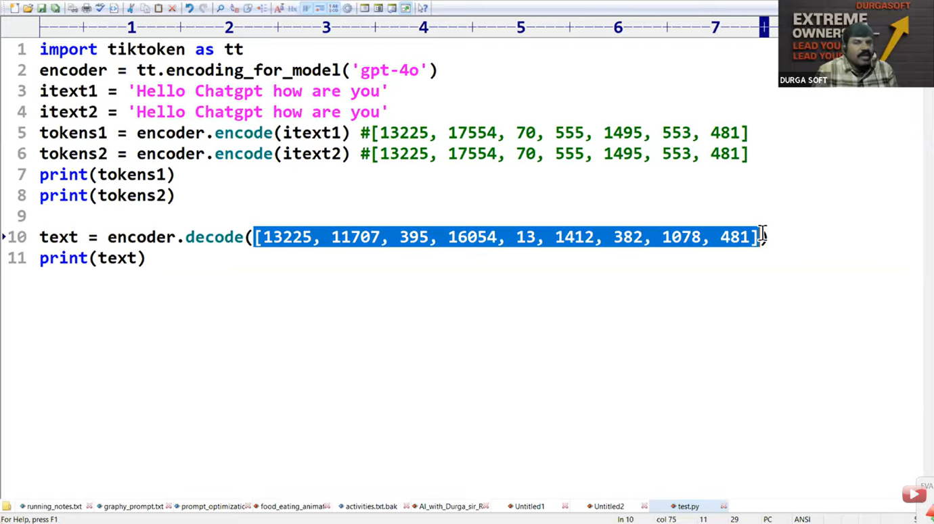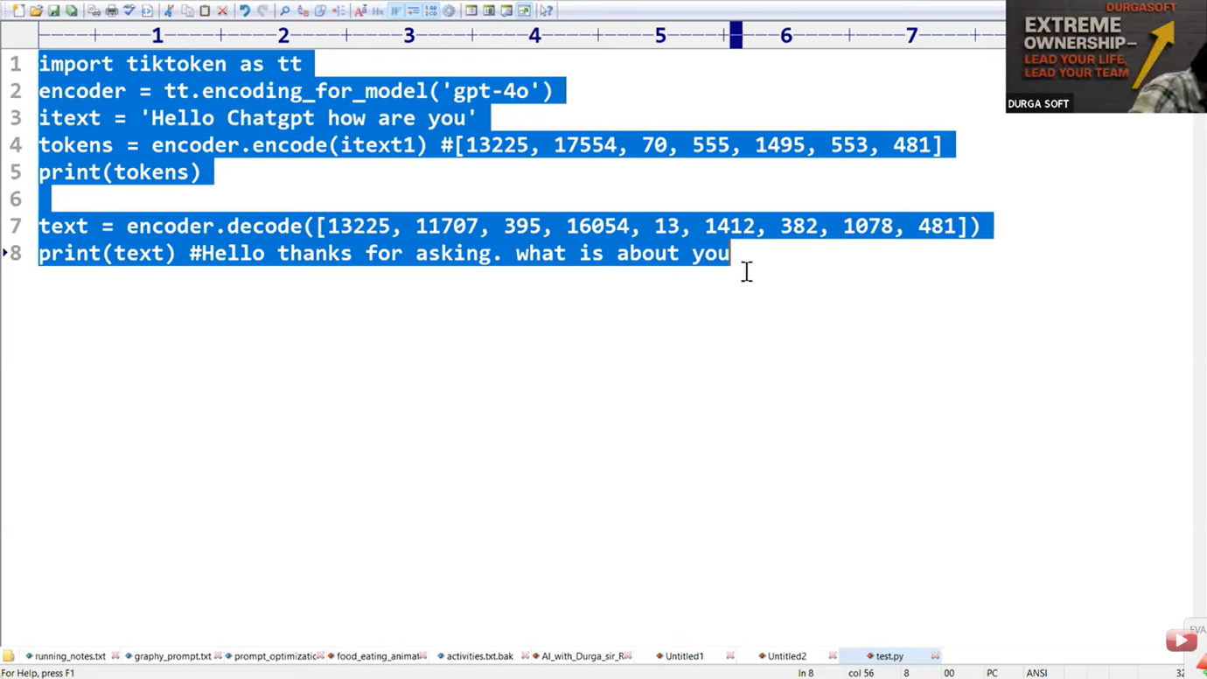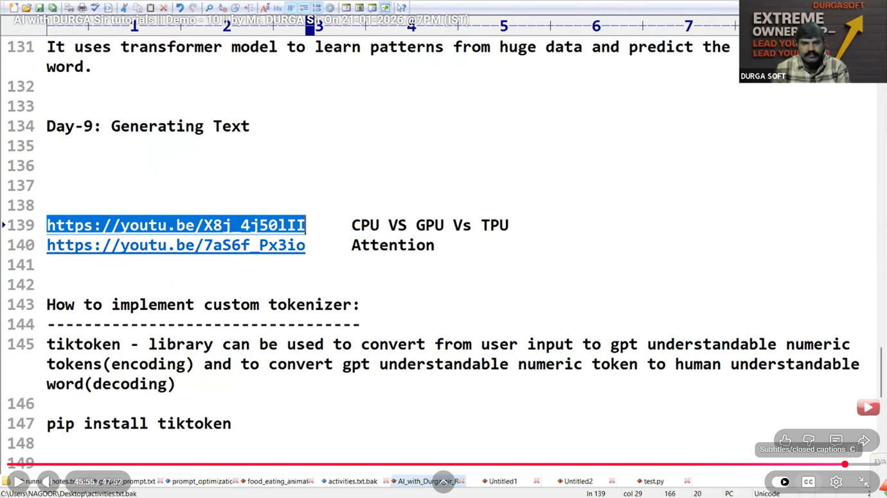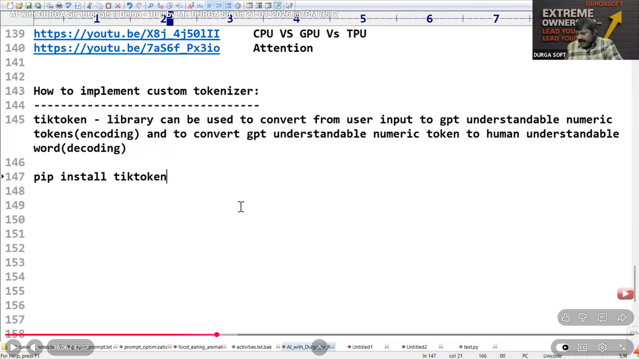

**Video 11**

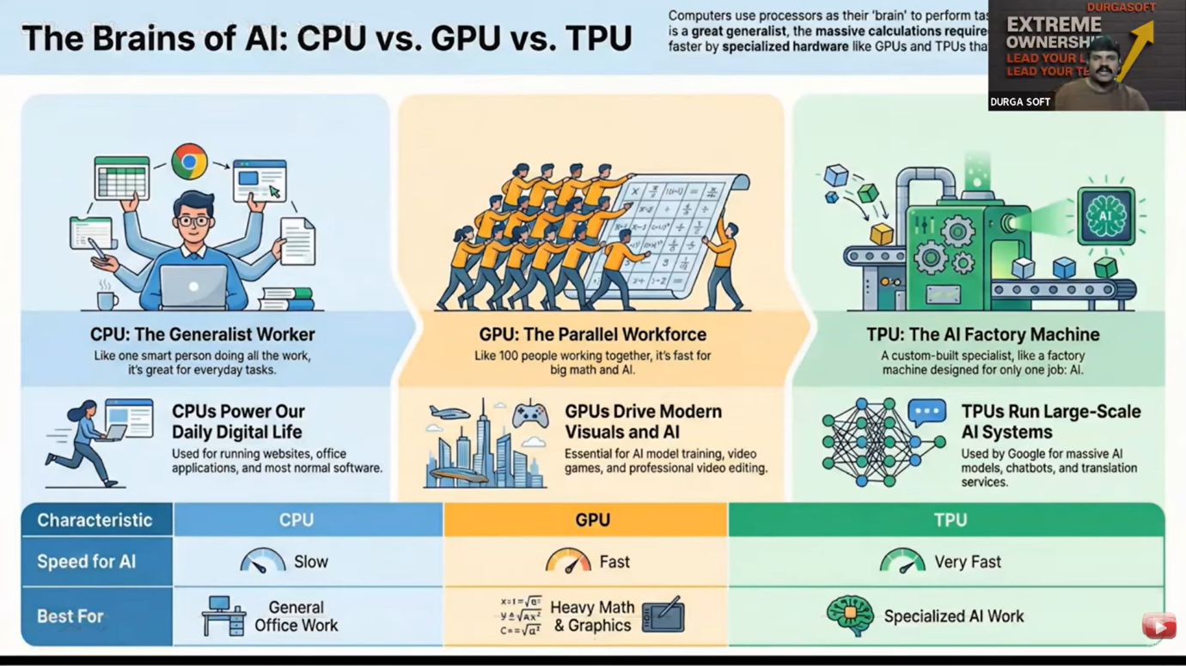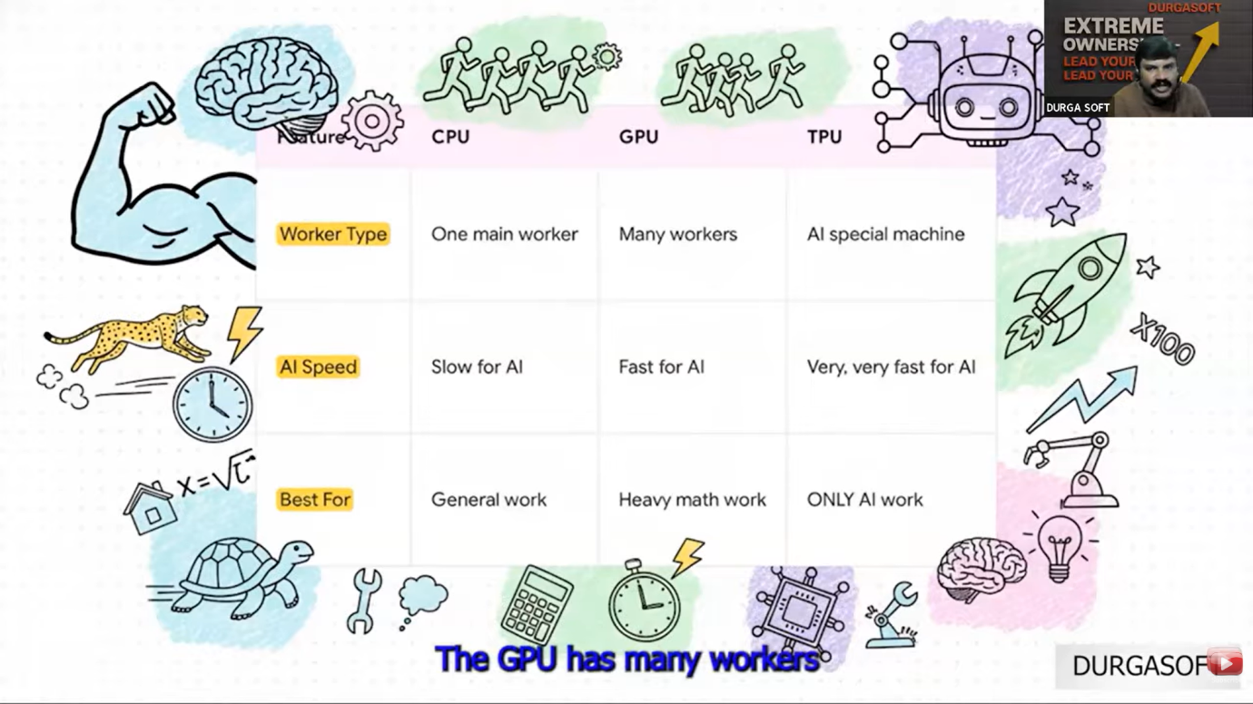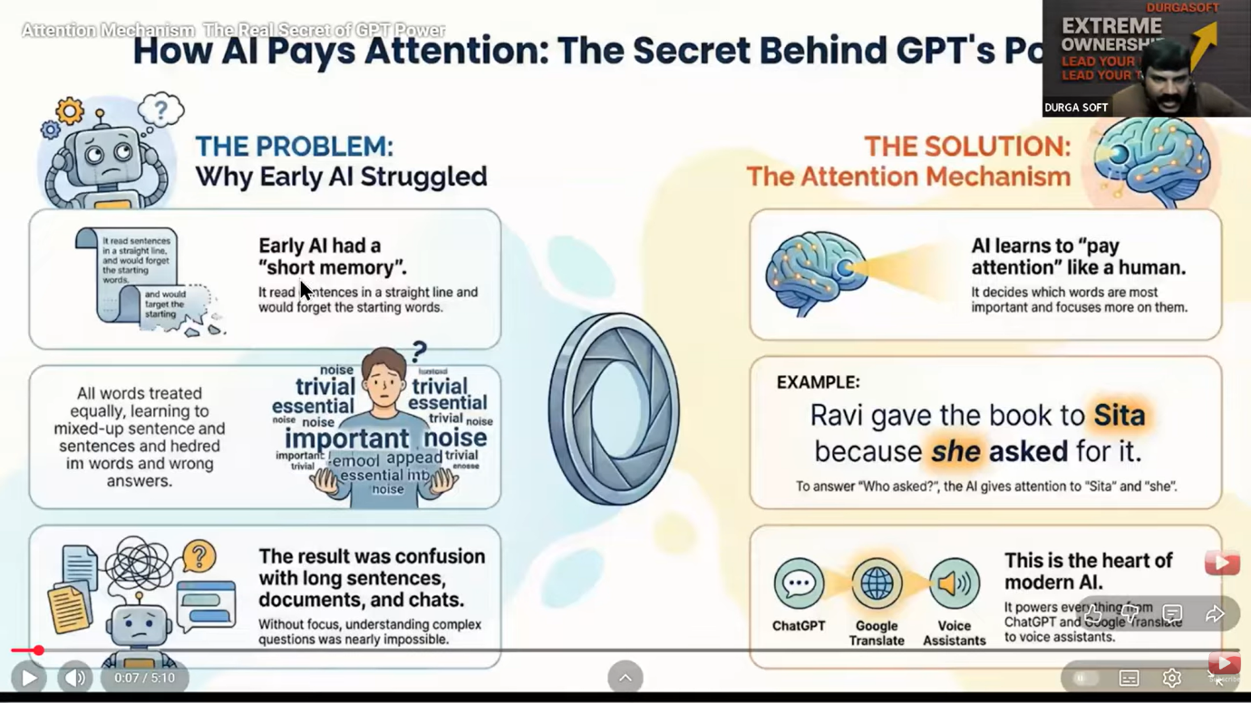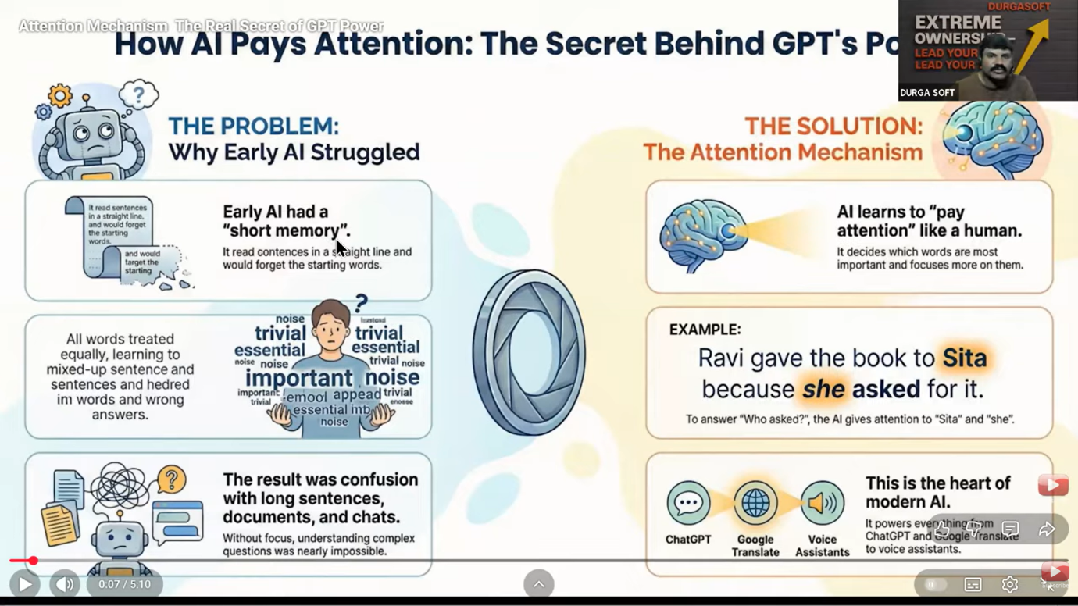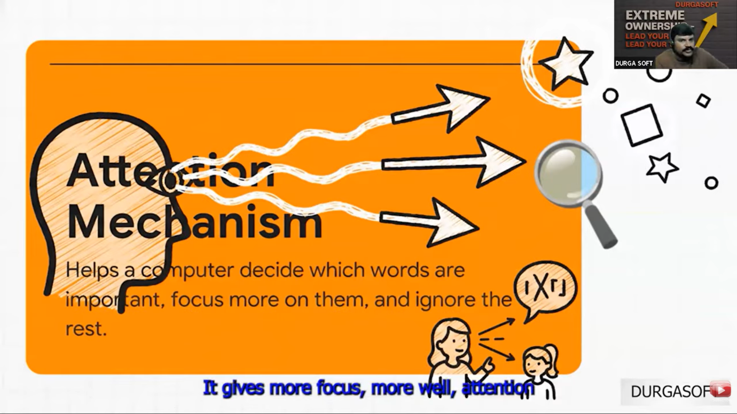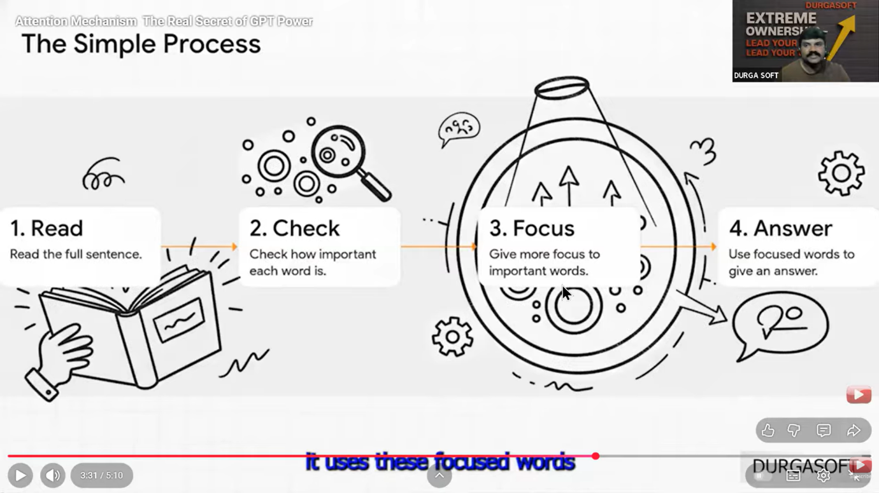

**Video 12**

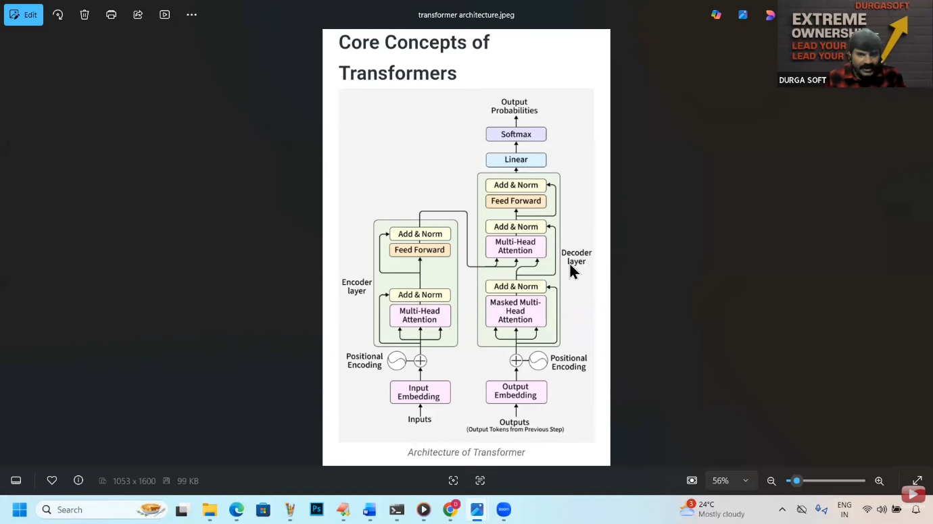

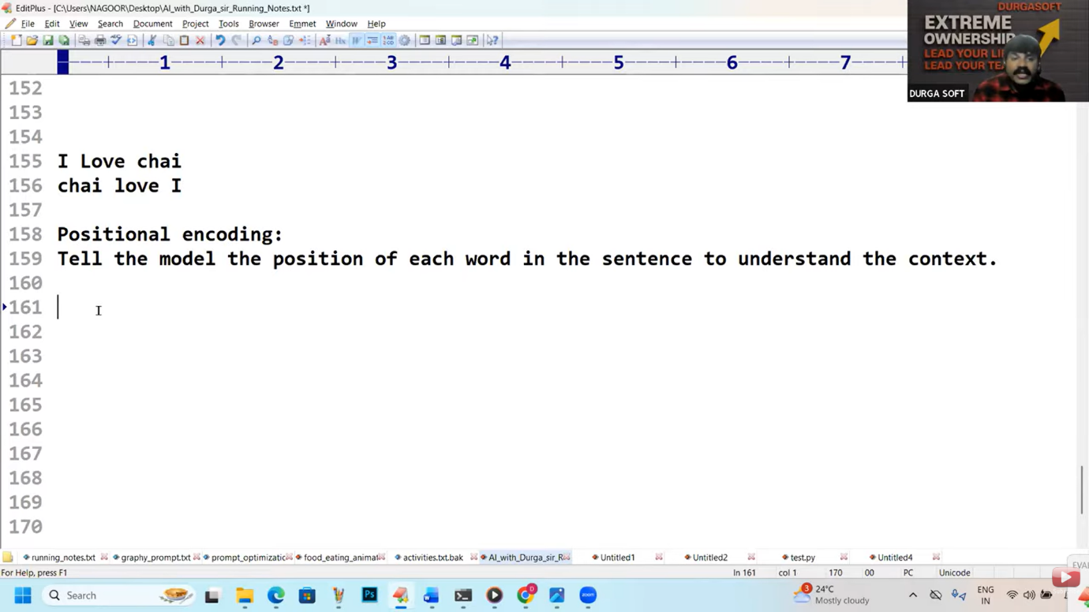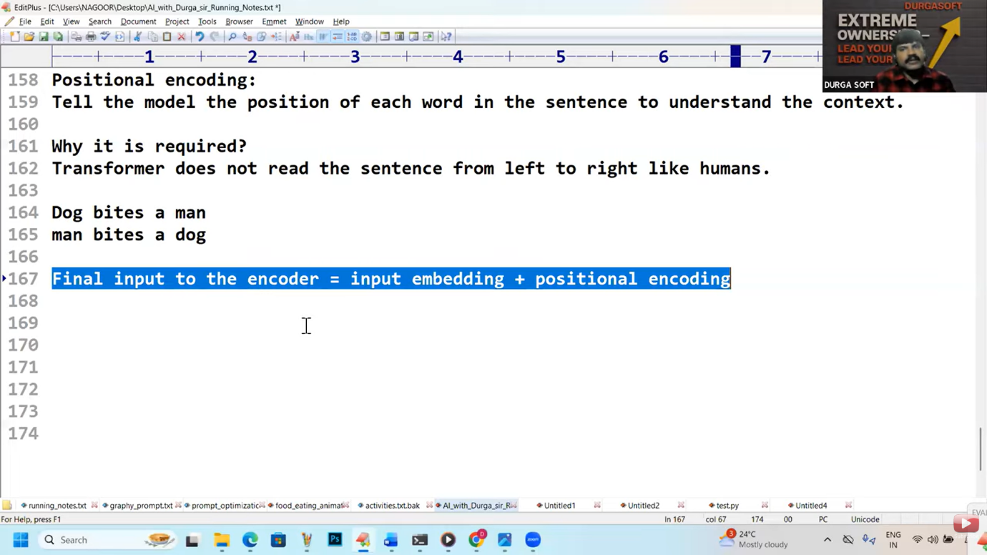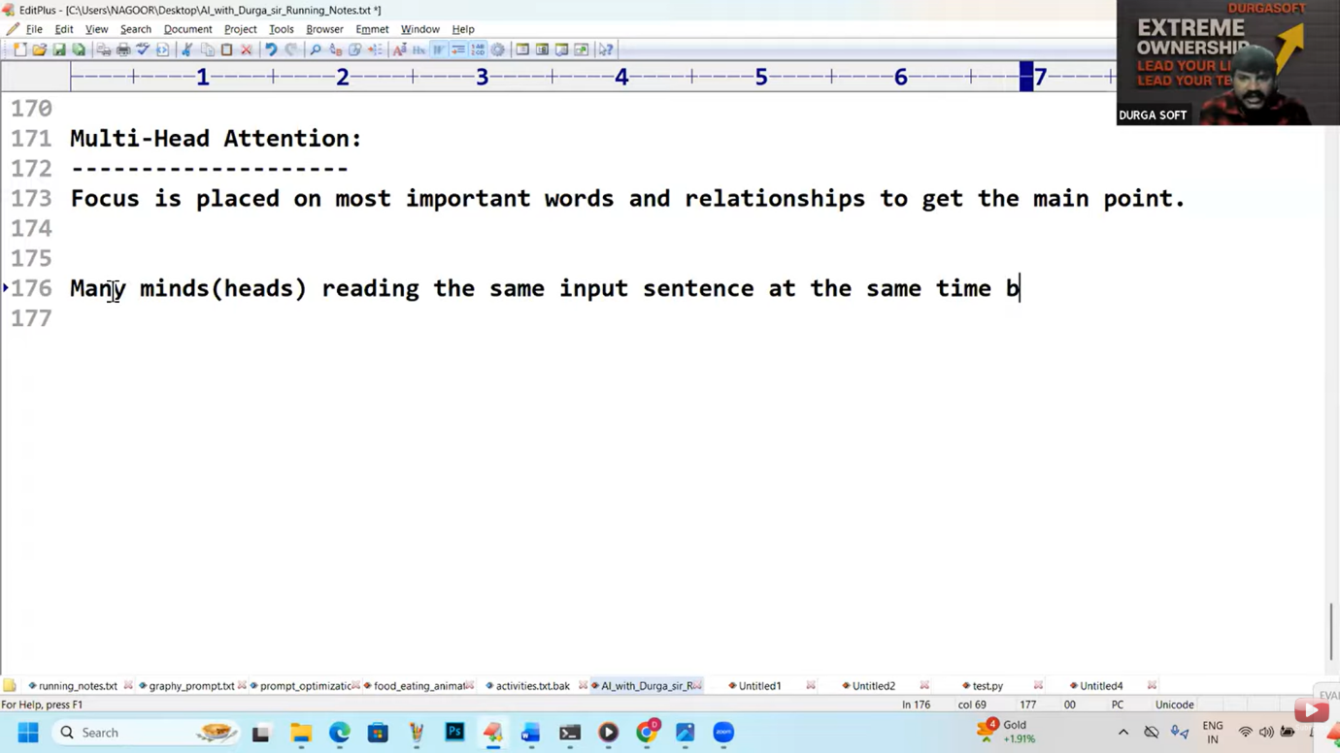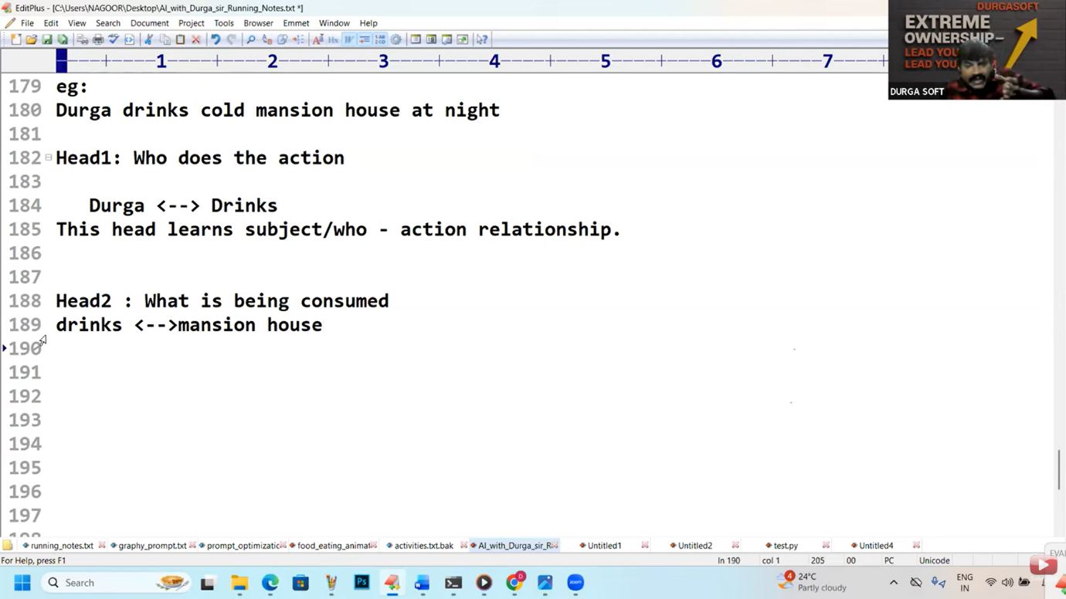

**Theorey  
  
https://youtu.be/X8j_4j50lII     CPU VS GPU Vs TPU**

**https://youtu.be/7aS6f_Px3io     Attention**

**How to implement custom tokenizer:**

**----------------------------------**

**tiktoken - library can be used to convert from user input to gpt understandable numeric tokens(encoding) and to convert gpt understandable numeric token to human understandable word(decoding)**

**pip install tiktoken**

**Dog bites a man**

**man bites a dog**

**I Love chai**

**chai love I**

**Positional encoding:**

**Tell the model the position of each word in the sentence to understand the context.**

**Why it is required?**

**Transformer does not read the sentence from left to right like humans.**

**Dog bites a man**

**man bites a dog**

**Final input to the encoder = input embedding + positional encoding**

**Multi-Head Attention:**

**--------------------**

**Focus is placed on most important words and relationships to get the main point.**

**Many minds(heads) reading the same input sentence at the same time, but each**

**mind looks for a different meaning.**

**eg:**

**Durga drinks cold mansion house at night**

**Head1: Who does the action**

**Durga <--> Drinks**

**This head learns subject/who - action relationship.**

**Head2 : What is being consumed**

**drinks <-->mansion house**

**This head learns action-object relationship**

**Head3 : Property / Quality**

**Cold <--->Mansion house**

**Learns attribute relation**

**Head4: Time**

**night -->drinks**

**Learns when this action happens**

**Head5 = type/category**

**mansion house -->drink type**

**This is liquid not a food**

**All these heads work in parallel to find the meaning and relationships.**

**Add and Norm:**

**------------**

**Add: We have to add attention output with original input**

**Add = original input+attention output.**

**Normalization:**

**keep values small and balanced**

**It prevents overflow and confusion.**

**Feed Forward:**

**------------**

**Each input word is individually refined.**

**Meaning is strengthend.**

**Durga ---> understand as a person**

**Drinks --->understand as action**

**cold ---> understand as quality/condition**

**mansion house -->understand as a drink item**

**at night --> understand as time information**

**Note:**

**Attention = Connecting words**

**Feed Forward = Polishing each word**

**1. Decoder Input:**

**----------------**

**Decoder does not start from zero**

**It takes already generated words.**

**First time it starts with a START Token.**

**2. Ouput embedding:**

**-------------------**

**Words are converted into numbers as transformer can understand only numbers.**

**3. Positional encoding:**

**------------------------**

**Position of word is added.**

**Without position meaning will be changed.**

**dog bites a man**

**man bites a dog**

**4. Masked multi head self attention:**

**------------------------------------**

**Decoder looks only at past words.**

**Future words are hidden(masked)**

**This masking concept is applicable at the time of training where total output statement is visible.**

**Maksing is not required at the time of using the model.**

**Masked attention hides future words so that model learns to predict, not copy.**

**Prevents cheating.**

**Add and Norm(After Masked Multi head attention):**

**-----------------------------------------------**

**Original input added back.**

**values are normalized.**

**Keep learning stable.**

**Avoids confusion.**

**Multi head attention(Encoder-Decoder attention):**

**----------------------------------------------**

**Decoder looks at encoder output.**

**Connects input meaning with output generation.**

**Helps generate correct and relavant words.**

**Feed forward network:**

**--------------------**

**Extra thinking layer.**

**improves understanding quality.**

**helps grammer and structure.**

**Linear:**

**-------**

**It is the last thinking step.**

**It converts model thinking into word scores.**

**It does not choose the word.**

**It only prepare options.**

**Softmax layer:**

**-------------**

**converts scores into probabilities.**

**Choose the best next word.**

**Highest probability word will be selected.**

**For each word, decoder does:**

**1. Look at past words (Masked Multi head attention)**

**2. Look at input meaning (cross attention | encoder-decoder multihead attention)**

**3. Think deeper (Feed forward)**

**4. Score all words(Linear Layer)**

**5. Pick one word( Softmax Layer)**

**Encoder input understanding: What is todays weather?**

**Decoder output : Rain is heavy**

**Step-0: START token**

**Tells the decoder**

**'start generating output'**

**You open the mouth to speak.**

**No word spoken yet.**

**Decoder has [START]**

**step-1:**

**------**

**Masked multi head attention look only past words.**

**No words generated yet**

**Decoder sees only [START]**

**Step-2: Cross attention[Look at encoder meaning]**

**you remeber the question**

**Describe todays weather?**

**Decoder thinks:**

**I must talk about weather.**

**Step-3: Feed Forward Network[Extra thinking]**

**Decoder thinks:**

**weather --- rain.. may be start with rain**

**Step4: Linear layer scores to all words**

**Rain**

**Sun**

**Wind**

**Softmax picks the best word: rain**

**Step-5: Masked Multi head attention(Second round)**

**Alreay said: Rain**

**Decoder thinks: Sentence is not complete**

**Decoder sees: Rain**

**Step-6: Cross attention:**

**Re checks input meaning**

**Avoids going off topic**

**Questions remainder: Describes todays weather?**

**Decoder thinks: I should describe rain**

**Step7: Feed forward:**

**Extra thinking layer.**

**Describes grammer pattern and structure?**

**Rain .... is ... something**

**step8: Linear + softmax:**

**-----------------------**

**Options:**

**is**

**was**

**falls**

**softmax selected is**

**Second word generated: is**

**Step9: Masked multi head attention(3rd round)**

**Keep track of sentence so far**

**Decoder sees: Rain is**

**Listener expects more**

**Step-10: Cross attention + Feed forward**

**Decide description word**

**Keep answer aligned to input**

**Decoder think: How is rain?**

**Step11: Liner + softmax**

**options:**

**heavy**

**sweet**

**fast**

**Third word generated: Heavy**

**Rain is heavy.**

**Video 14 Quizz  
  
